A study of a passive heating design employing a Trombe wall with PCM: A numerical investigation of the semi-oceanic climate in Morocco

Author ¹, Author ², Author ³.

Affiliation1
Affiliation2
Affiliation3

Abstract(300 word limit)
As living standards continue to rise, there is an increasing demand for thermal comfort in buildings, which raises energy consumption, especially in severe climates. Passive systems have received much attention since they may give the necessary level of comfort while being environmentally beneficial. The Trombe wall, a passive heating idea for cold climates, is the best way to reduce energy consumption since it captures solar energy that will later be transferred to the interior space. While it can raise indoor temperatures in the heating season, it produces excess heat in the cooling season, which makes summer comfort less pleasant. Several measures should be adopted to prevent overheating and maintain a balance between heating and cooling throughout the year. Phase Change Materials (PCM) must be utilized to incorporate a light storage wall into the Trombe wall while keeping a tolerable interior temperature owing to their ability to maintain the indoor temperature and store energy in the form of latent heat. A 3 cm air gap, a 0.9 m sunshade, and RT 28 HC product with a melting temperature range around (27 - 29 °C) as paraffin PCM were the best options employed in a Trombe wall for a semi-oceanic climate to reduce the energy demand. The annual energy consumption for the reference single-room house decreases from 1285.6 kWh to 733.18 kWh when vents are added to the PCM Trombe wall, which results in a savings of 42.97%.

Please insert Image/Figure
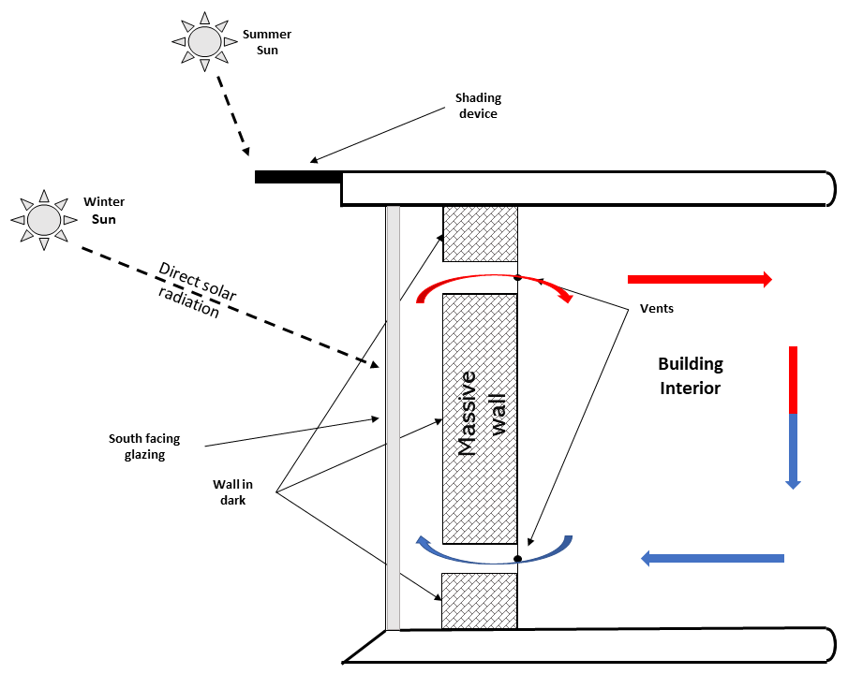
Recent Publications (maximum 5)
- Mabrouki, A. et al. (2022) “A study of a passive heating design employing a Trombe wall with PCM: A numerical investigation of the semi-oceanic climate in Morocco,” Materials Today: Proceedings [Preprint]. Available at: https://doi.org/10.1016/j.matpr.2022.08.410.
- Abdellaoui, Y. et al. (2022) “Assessment of graphene oxide clay wall performance as an efficient active heating system,” Materials Today: Proceedings [Preprint]. Available at: https://doi.org/10.1016/j.matpr.2022.08.393.
- Benmoussa, Y. et al. (2022) “Simulation of an energy-efficient cool roof with cellulose-based daytime radiative cooling material,” Materials Today: Proceedings [Preprint]. Available at: https://doi.org/10.1016/j.matpr.2022.08.411.

Biography(150 word limit)
Author has her expertise in evaluation and passion in improving the bone and cement used in dental medicine. Her focus is based on the use of natural phosphate to have application in health field. She was warded her PhD in 2013 from the University of …., Country. She published more than 20 papers. Her H-index is X on Scopus.
Email: drXXXXXXX@xxxmail.com

